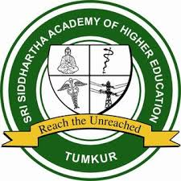
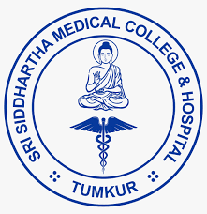

CONFERENCE REPORT

PesuCon 2023
18th Annual conference of the IAPS KSC

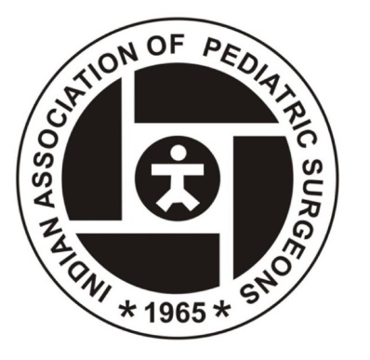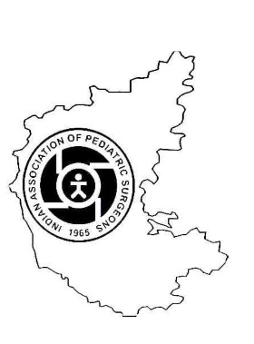

Organized by:
Department of Paediatric Surgery,
SRI SIDDHARTHA MEDICAL COLLEGE, SSAHE, TUMKUR,
IN ASSOCIATION WITH IAPS-KSC

On
01, 02 & 03 December 2023

Venue
Nagarjuna Hall,
Sri SiddharthaAcademy of Higher Education,Tumkur, Karnataka and Ankit Vista Resorts, Nelamagala

Table of contents

S. No | Content | Page No.
1 | Background | 1
2 | Aim and Objectives | 2
3 | Participant Details | 2
4 | Proceedings | 3-16
 | a) Pre-Conference Workshop | 3
 | b) Inauguration | 4
 | c) Welcome address | 5
 | d) Programme schedule | 6-8
 | e) Scientific sessions | 9-12
5 | Research Paper and Poster presentation | 13-15
6 | Cultural activities | 16-18
7. | Valedictory | 17-18
 | a) Conference proceeding report | 17
8. | Feedback analysis | 19-20

Background

Sri Siddhartha Medical College (SSMC) and Hospital, Tumkur was established
in 1988 under the aegis of the Sri Siddhartha Educational Society, with the aim
of developing and nurturing quality medical professionals committed to
excellence in health care and social welfare.

Nestled in a 250-acre green campus, spread over 75,000 sqmts, the college
today evolved into a renowned hub of higher education and health care in India
under SSAHE. This prestigious campus is just an hour’s drive (76kms) from
Bengaluru city, situated off Bengaluru – Honnavar National Highway. The
medical college team comprises of a dedicated team of faculty members who
are equipped to coach their wards in both clinical and academic aspects with
the vision of “Entrancing Education to Reach the Unreached”

IAPS KSC is a subchapter under the umbrella of IAPS which is a non governmental organisation which includes specialist doctors dealing with surgical diseases in the paediatric age group including neonates. Paediatric surgical association of Karnataka has been there for more than 2 decades which camaigns for the surgical diseases of the children. It attempts to update its fellow members about the latest practices on pediatrci surgical care. It will certainly improve our own healthcare services & establish clear directions in meeting those Important challenges in the years to come.

Aim
To provide an opportunity for Health Care Professionals to learn and exchange Knowledge from experts in the field of Paediatric Surgery.

Objectives
1.To offer a platform for researchers, to share their research findings to encourage further research in the field of paediatric surgery and allied branches including paediatrics and its subspecialities
2. To offer a chance for Health Care Professionals to expand their network, a crucial aspect for paediatric surgery, which remains a nascent specialty in India
3. To familiarize the participants with management of common paediatric surgical problems including emergencies, palliative care, comprehensive surgical care and recent advances.
4. To provide a perspective on social, medico legal and spiritual dimensions in the care of children.

Participants-
The event brought together total 110 participants among which 70 were delegates from various institutions across the country, 30 from allied branches, PG and UG volunteers.

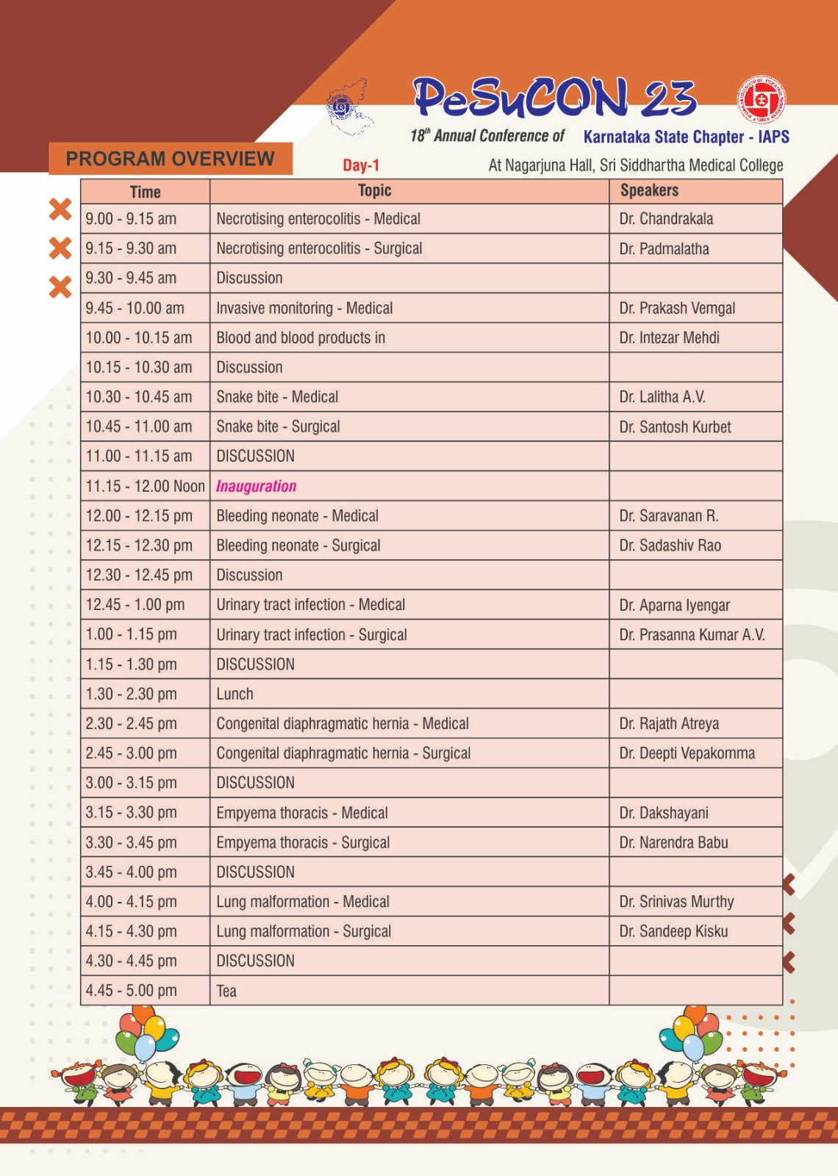

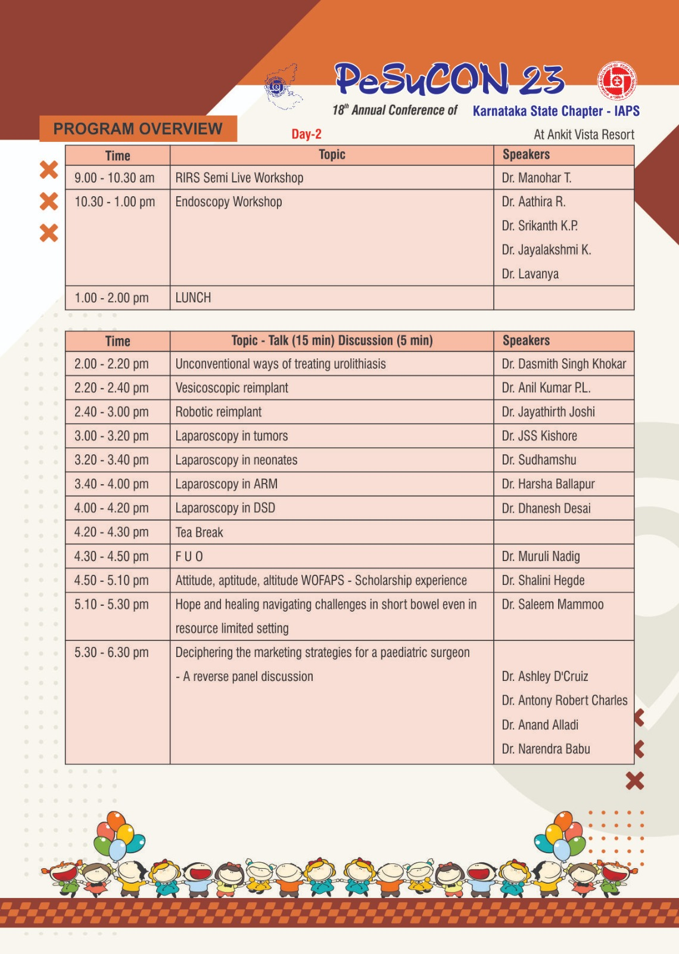

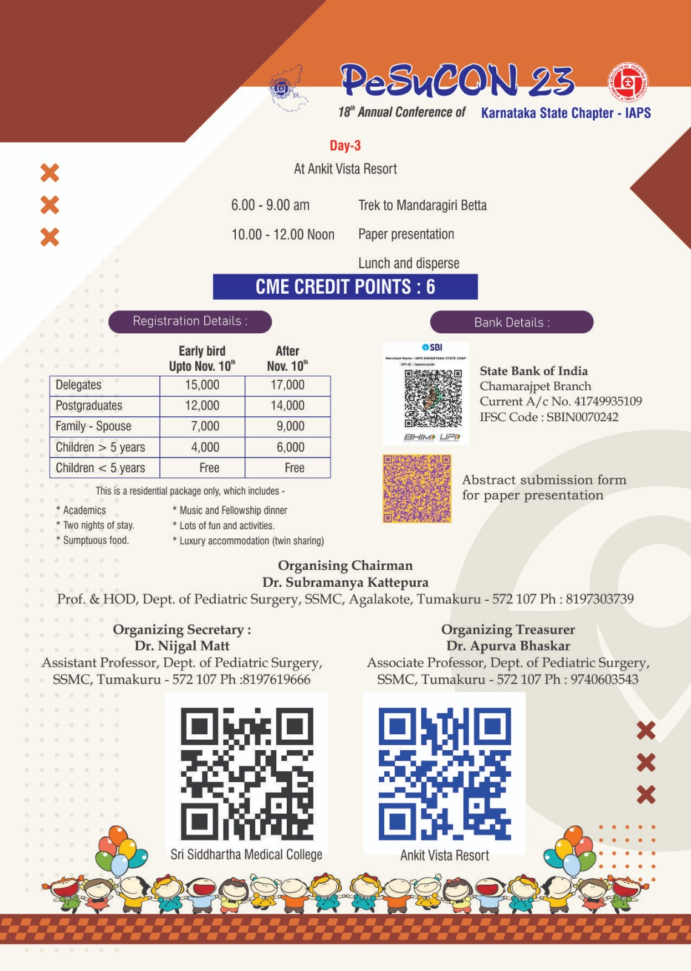

SCIENTIFIC SESSIONS:

DAY 1 – 01/12/2023

The conference was held at Sri Nagarjuna Hall, SSMC, Tumkur. The guest of honour was Dr G Parameshwara Hon'ble Chancellor, Sri Siddhartha Academy of Higher Education. The lighting of the lamp was done by Dr Linge Gowda K B , Vice Chancellor, SSAHE, Dr M Z Kurian , Registrar, SSAHE, Dr Gurushankar ,Controller of examiner, SSAHE, Dr Mallikarjun Sanikop ,Principal, SSMC, Dr Prabhakara G N , Vice principal, SSMC, Dr Ramesh Babu, IAPS national president, Dr Vikesh Agarwal, Secretary general, IAPS, Dr Narendra Babu, Chairman IAPS KSC, Dr Subramanya K, IAPS KSC secretary, Dr N S Venkatesh , Medical Superintendent, SSMC & H, Dr Vivek Veeraiah , Advisor to Chancellor, SSAHE and Organizing chairpersons Dr Subramanya K, HOD paediatric surgery, and Organising secretary Dr Nijagal Mutt J B, Assistant Professor , Dept of Paedaitric Surgery and Dr Apurva Bhaskar, Organising Treasurer, Associate professor, Department of Paediatric Surgery.

Welcome Address:

The welcome address was rendered by Dr Subramanya K, HOD, Department of Paediatric Surgery and the organising secretary, IAPS KSC. He began by welcoming the dignitaries, delegates and the guest speakers. He highlighted the importance of holding the conference on the topic of Paediatric Surgery.
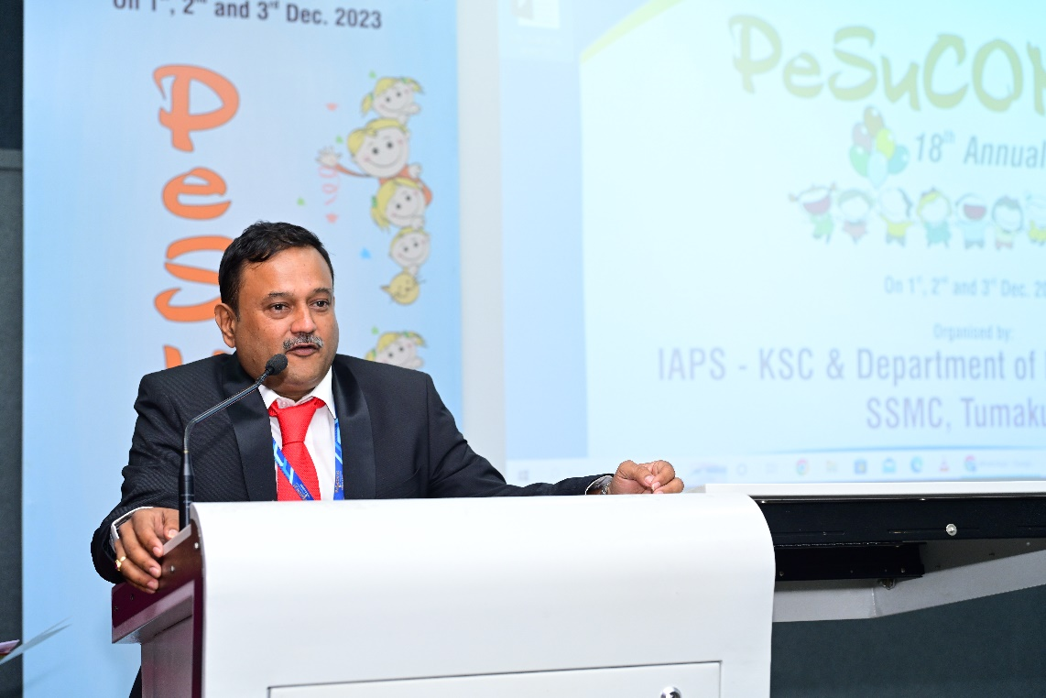

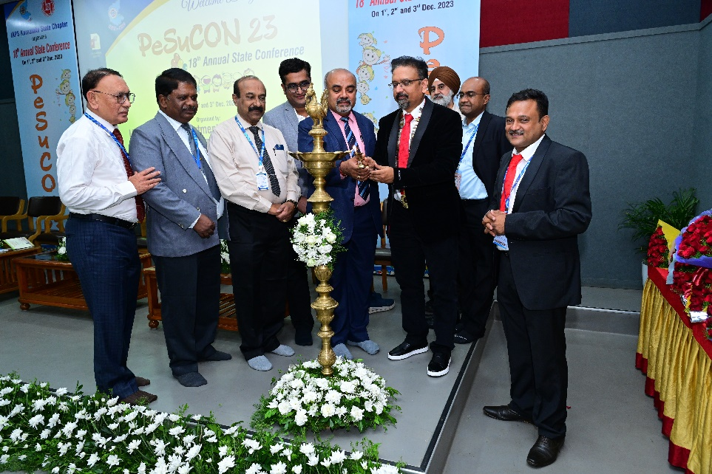

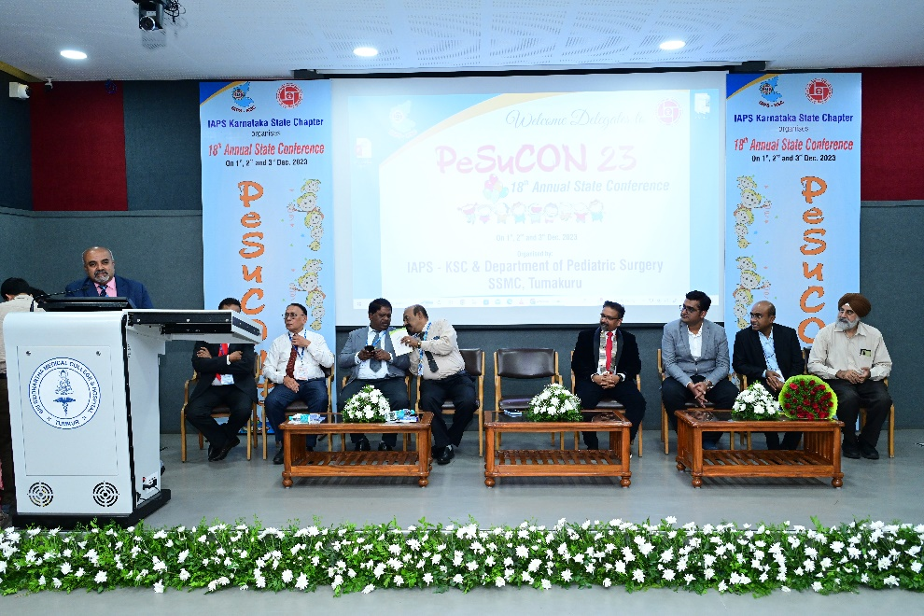

The chief guests and the dignitaries on the dias spoke on the importance of paediatric surgery and the need of paediatric surgeon at all levels in the country.
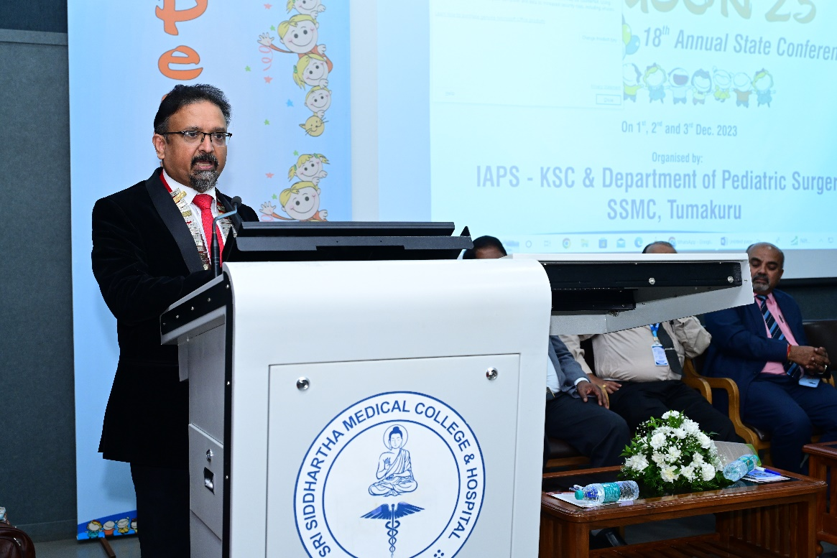

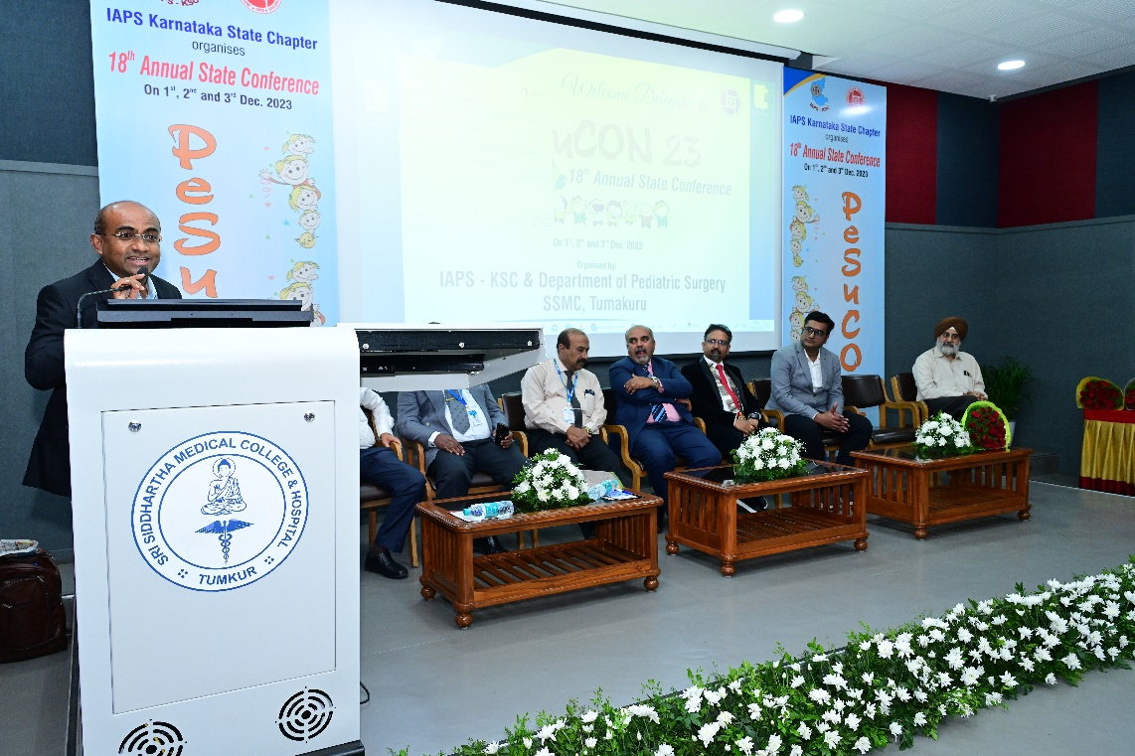

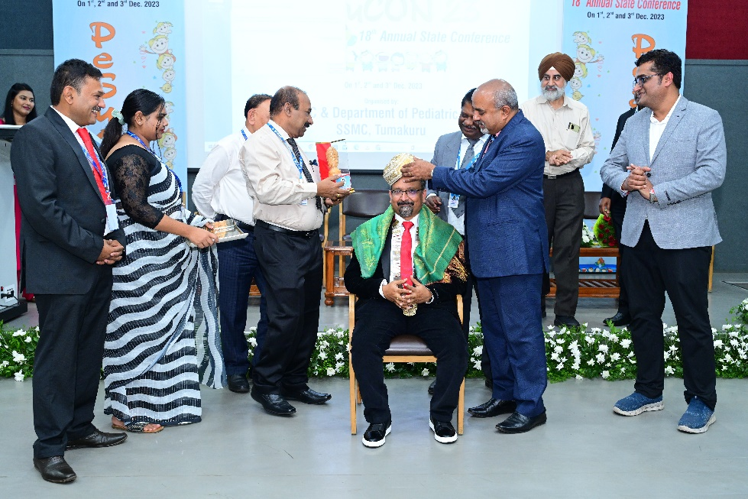

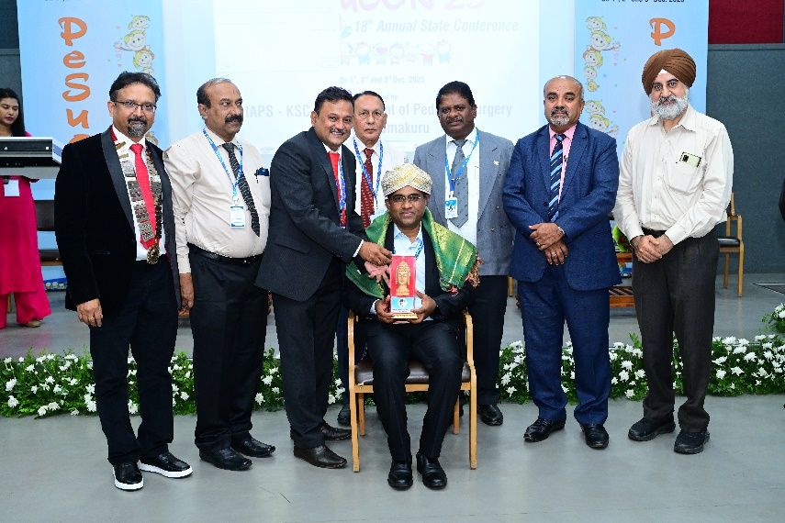

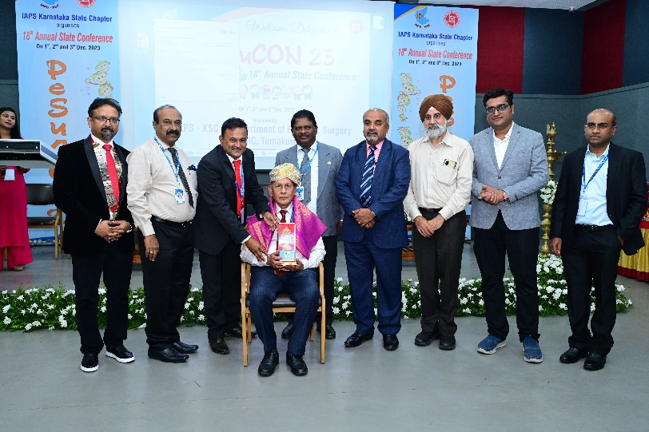

The IAPS president Dr Ramesh Babu spoke on the importance of paediatric surgery and urology. And it was seconded by Dr Vikesh Agarwal, Secretary General, IAPS. All guests on the dias were felicitated and inauguration was concluded witjh vote of thanks.
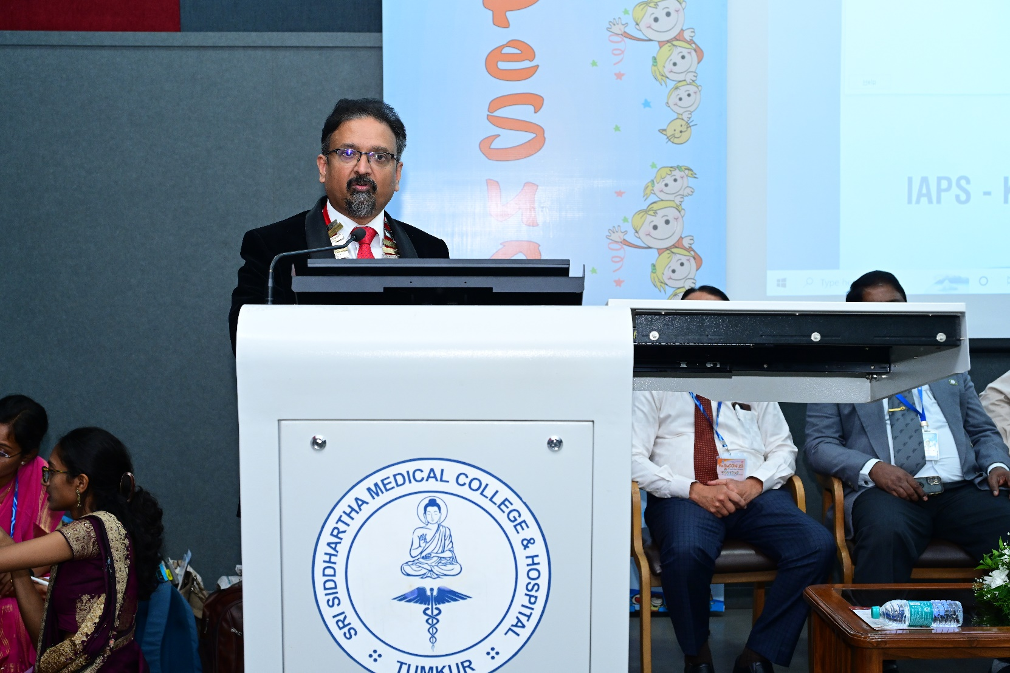

Scientific Sessions

Session - 1

Necrotisong Enterocolitis

Dr. Chandrakala , a senior neonatologist spoke regarding the medical aspects and the management of NEC in NICU as a neoantologist. Dr Padmalatha spoke on the surgical aspects of the same

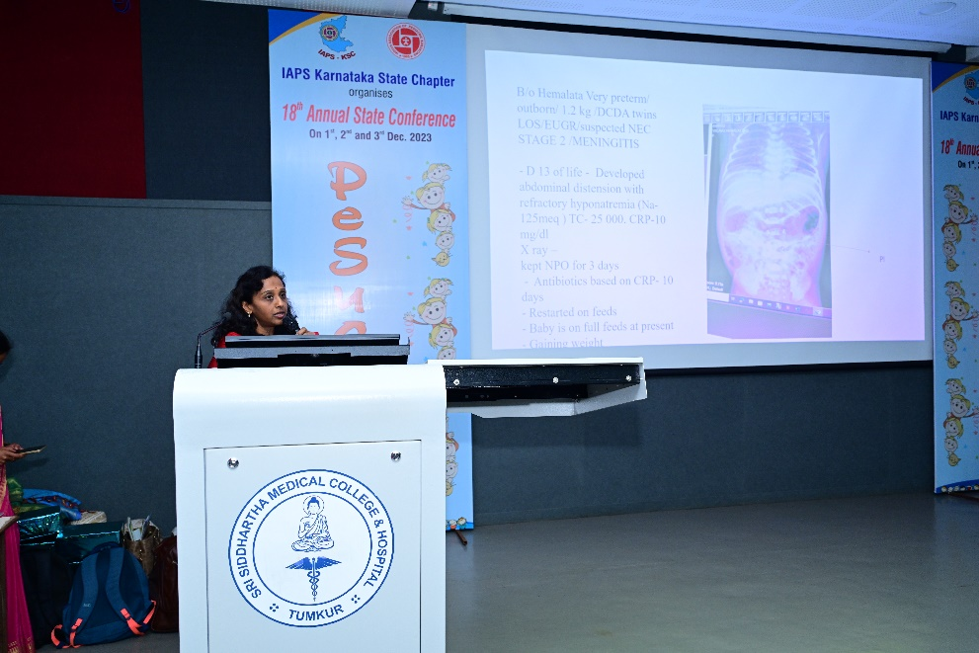
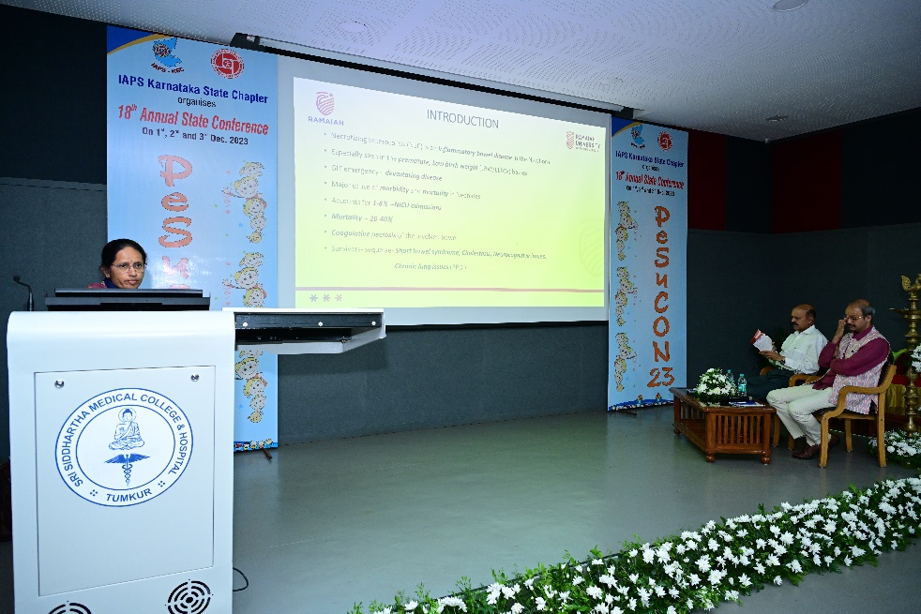

Session - 2
Snake bite
Dr Lalitha, Senior Paediatrician spoke on the medical management of varied presentations of different presentations of various snake bites. Surgical aspects of the same were spoken by Dr Santosh Kurbet.

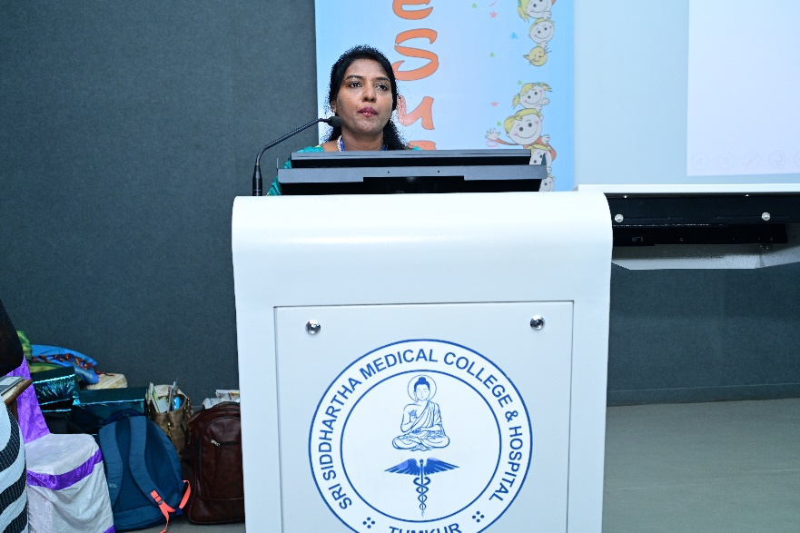

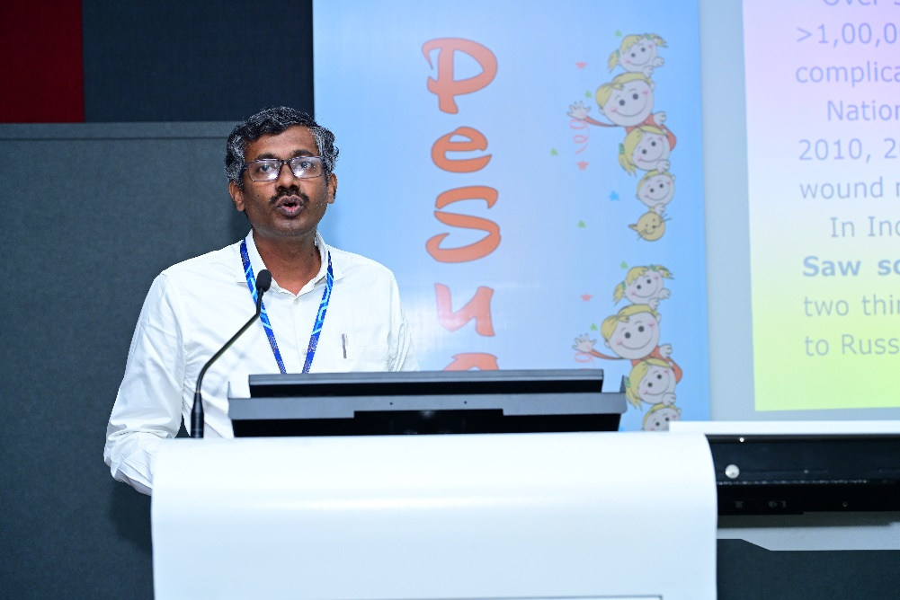

Session - 3
Bleeding neonate
Dr Saravanan and Dr Sadashiva Rao spoke on medical and surgical management of a bleeding neonate respectively.
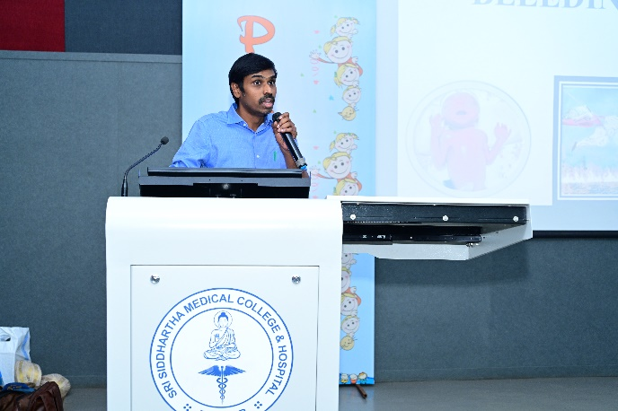

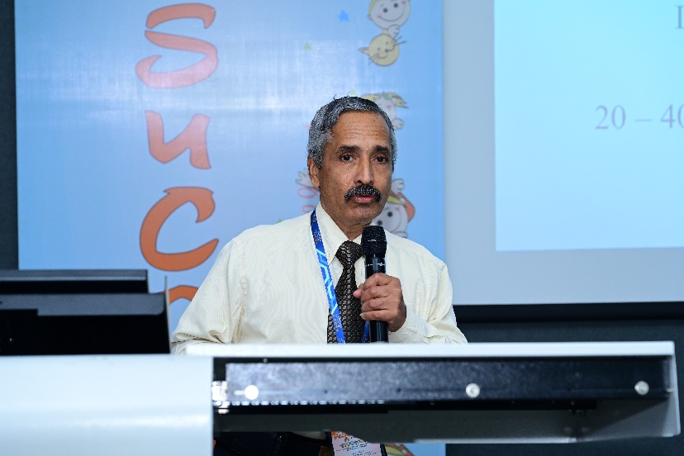

Session – 4
Invasive Monitoring

Dr Prakash Vemgal gave an in-depth insight into basics and advances in invasive monitoring of a child.

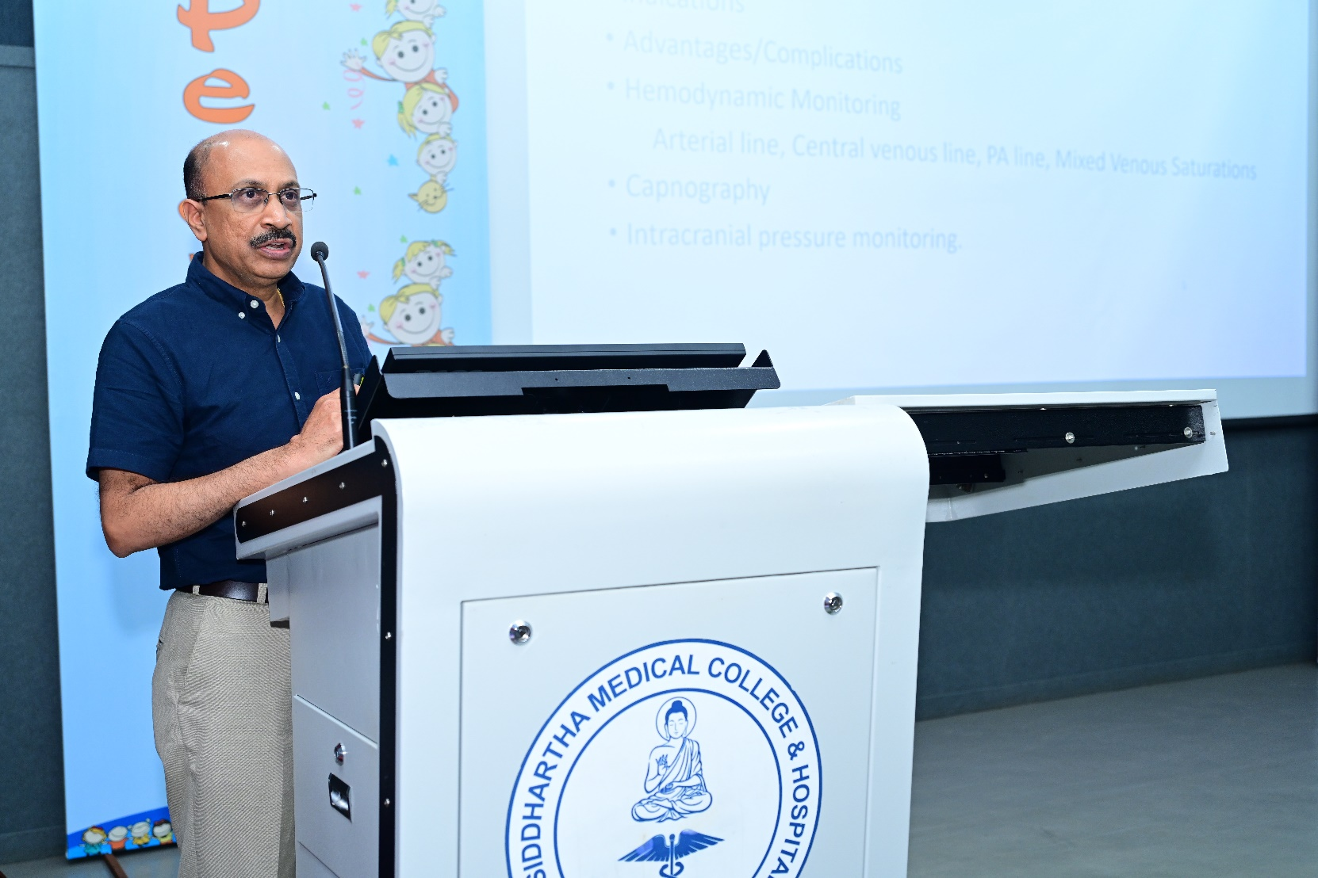

Session 5
UTI

Dr. Arpana Iyengar and Dr Prasanna Kumar from St Johns Medical College gave a detailed talk on the management of UTIs in children.
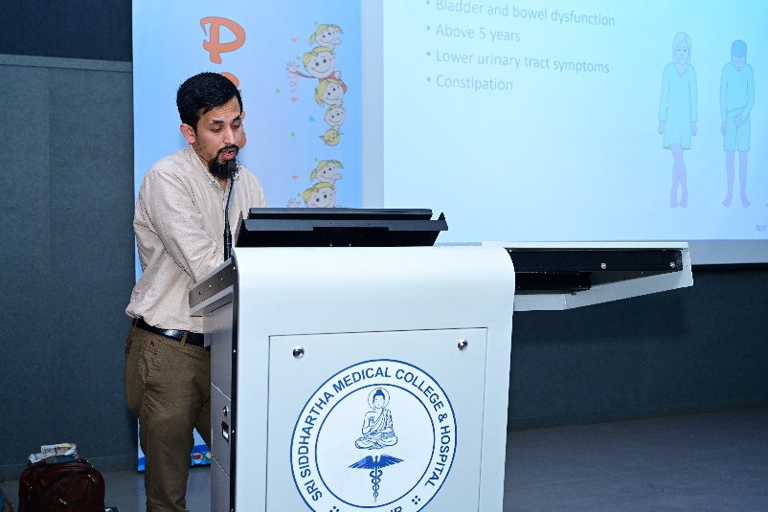

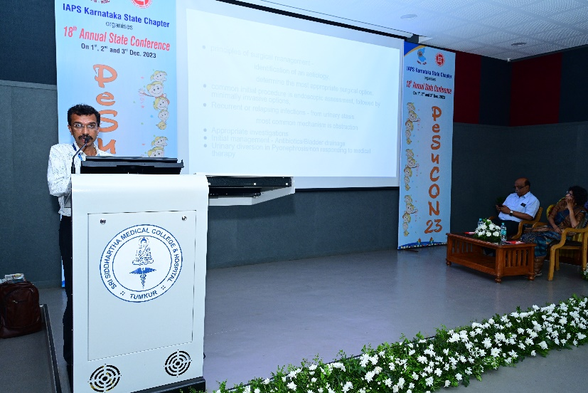

Session - 6
Blood and blood Products

Dr Intezar Mehdi senior consultant spoke the rational use of blood and blood products in paediatric population.

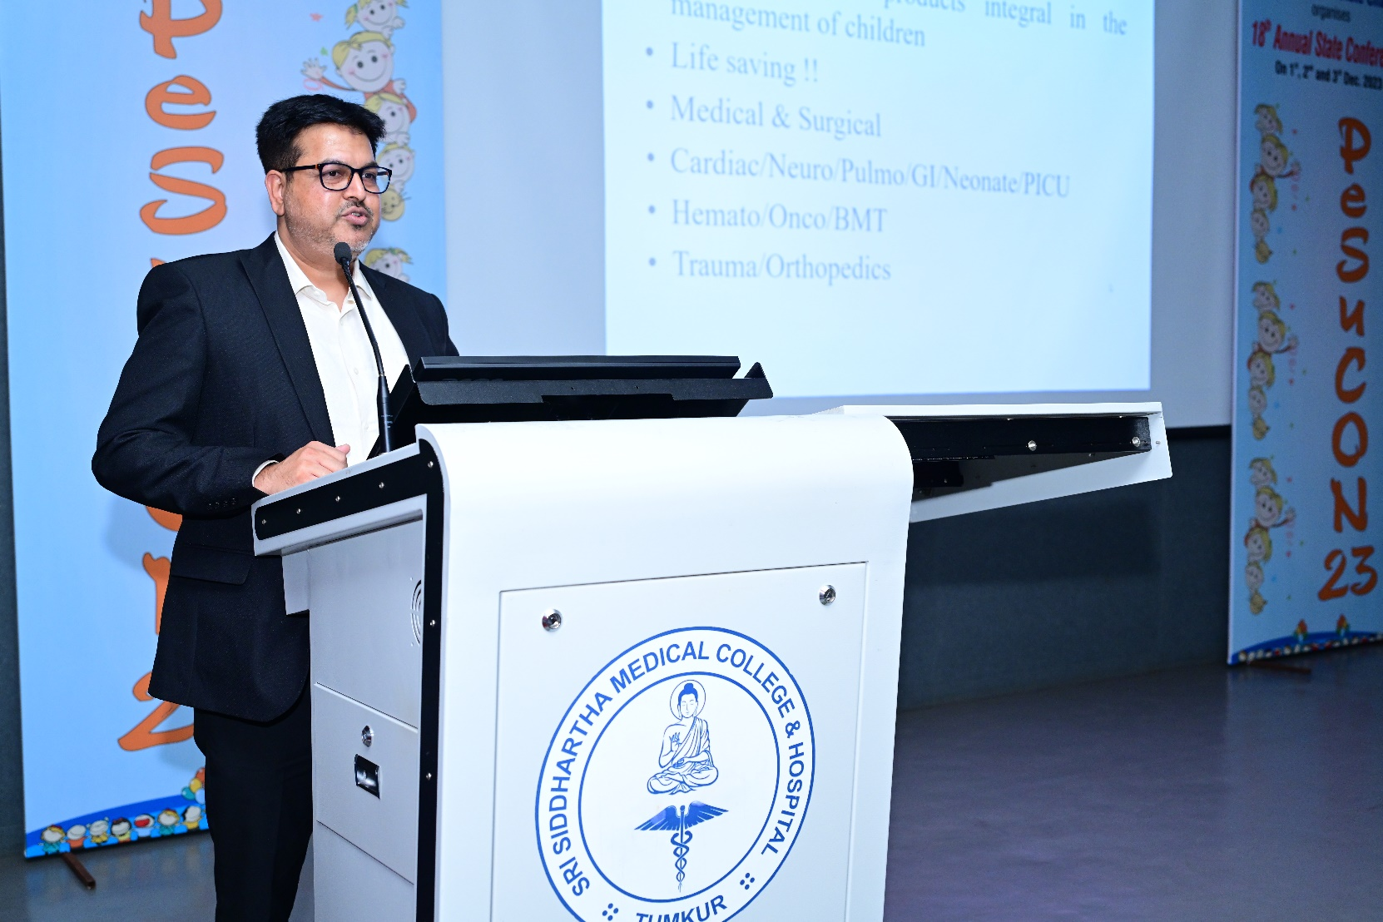

Session - 7
Congenital Diaphragmatic Hernia

Dr. Rajath Atreya and Dr Deepthi Vepakomma gave a talk on the medical and surgical management of CDH in neonatal population.

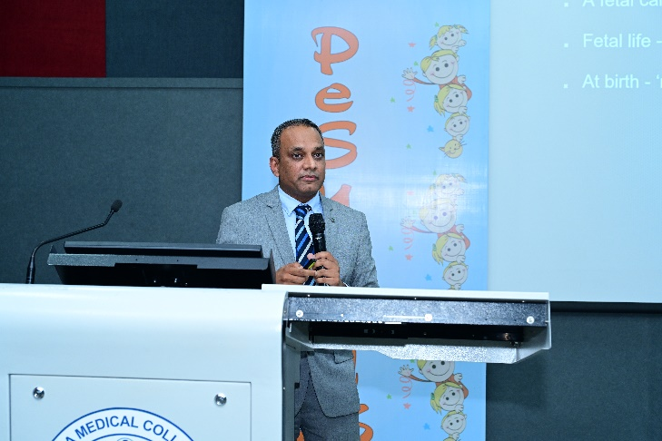

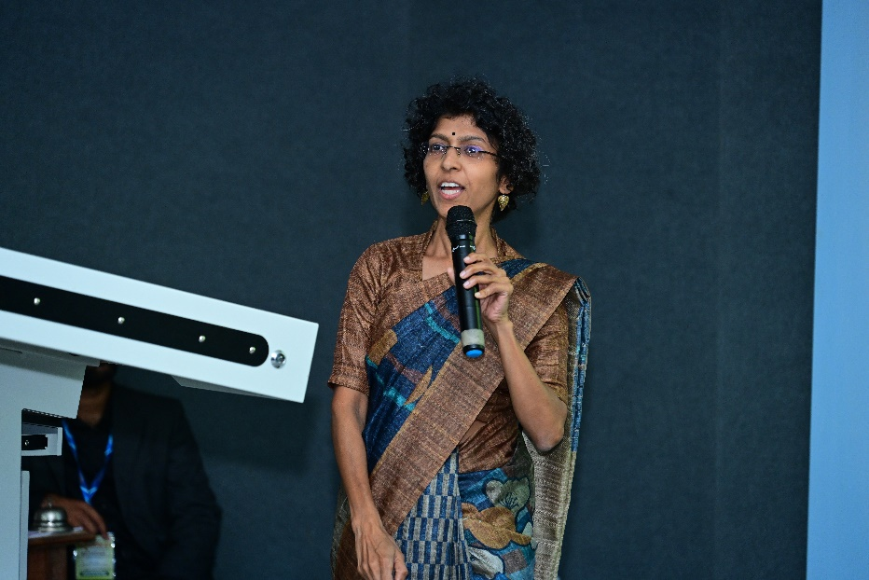

Session - 8
Empyema Thoracis

Dr Dakshayini and Dr Narendra Babu gave a detailed description on the medical and surgical management of empyema thoracis in paediatric population.

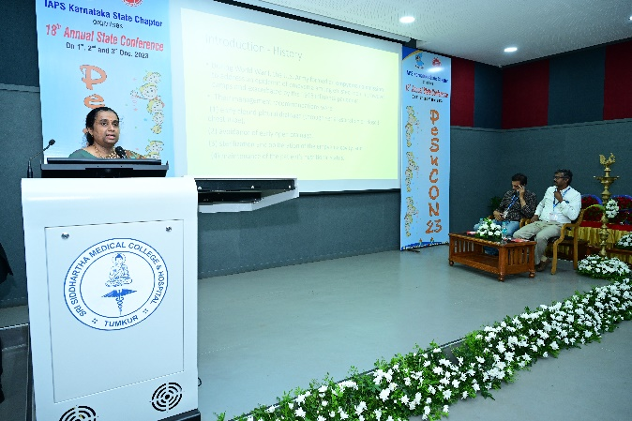

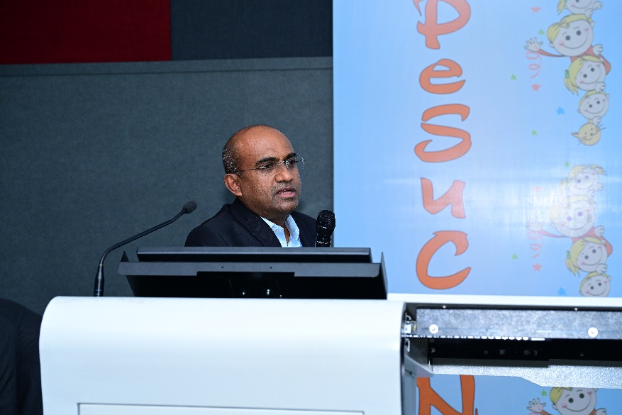

Session - 9
Lung malformation

Dr . Srinivas Murthy and Dr Sundeep Kisku gave a talk of the thoracic malformations.

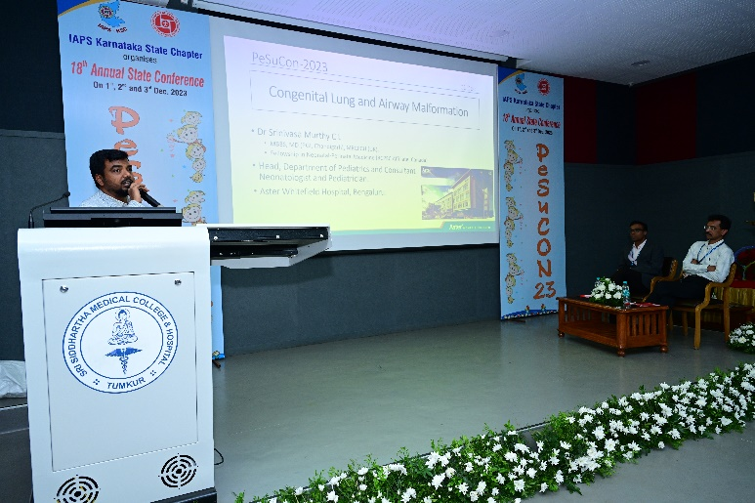

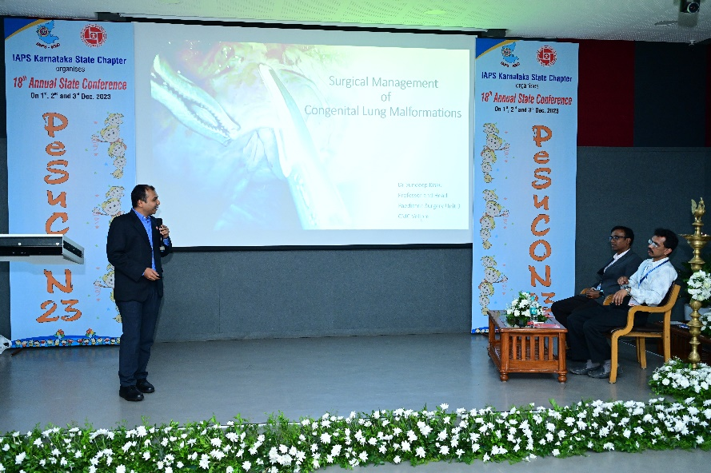

DAY 2 -12-02-2023

PROCEEDINGS

Conference workshop 9am-1.30pm
A Paediatric gastro and urology workshop was held in Ankit Vista Village, about 65 delegates were benefitted from the workshop, they were trained by experts in the management of RIRS by Dr Manohar T, Paediatric endoscopy by Dr Jayalaxmi, Dr Srikanth, Dr Lavanya and Dr Sahana We have received good feedback from all the participants.

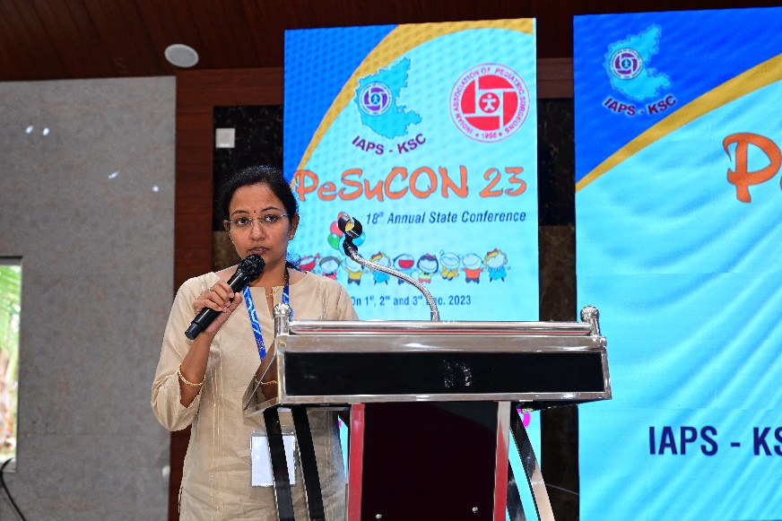
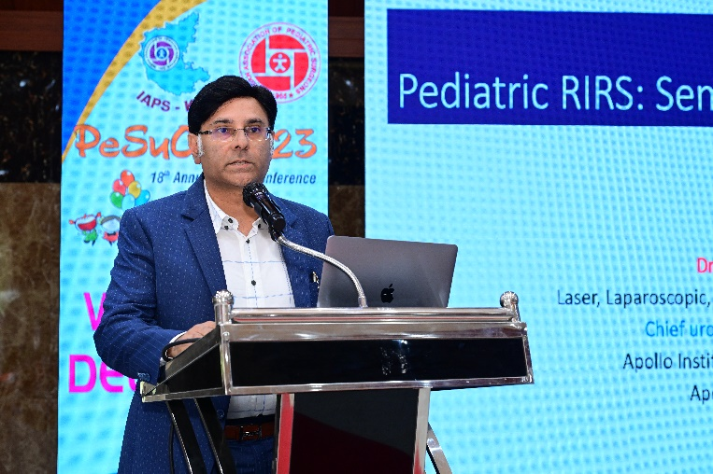

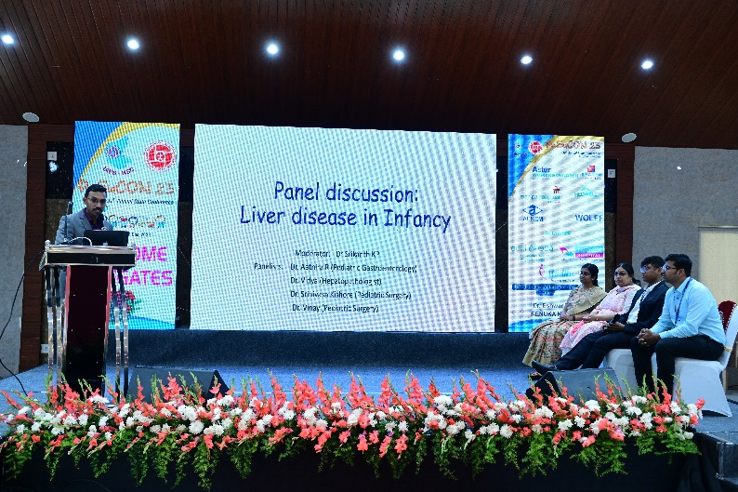

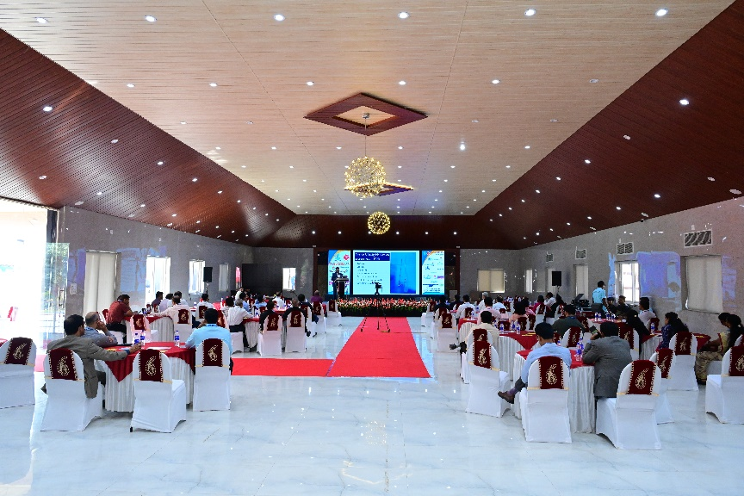

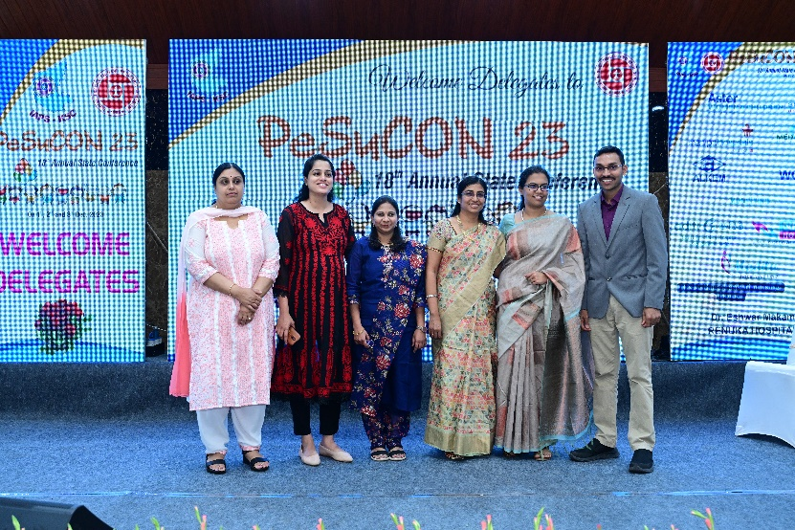

Second session 2pm to 5pm

Various talks on scopy in paediatric surgery were given by eminent personalities like Dr Dasmit, Dr Anil PL, Dr Jayateertha Joshi, Dr Kishore, Dr Sudamshu, Dr Harsha B.
General topics about scholarship experience by Dr Shalini which was well received by all. There was a reverse panel discussion on ‘Deciphering the marketing strategies for a paediatric surgeon’conducted by Dr Ashley, Dr Robert, Dr Anand Alladi and Dr Narendra Babu.

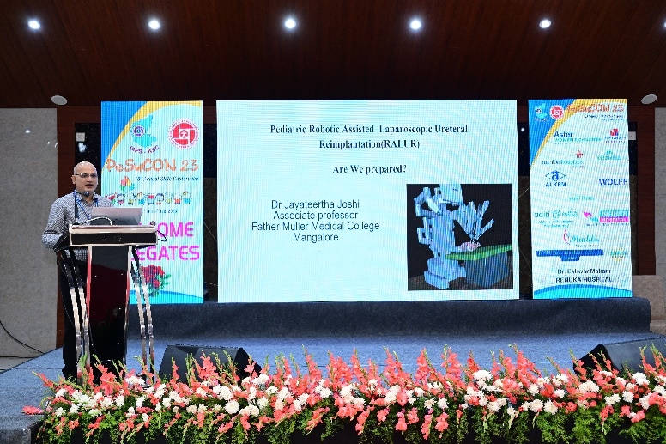

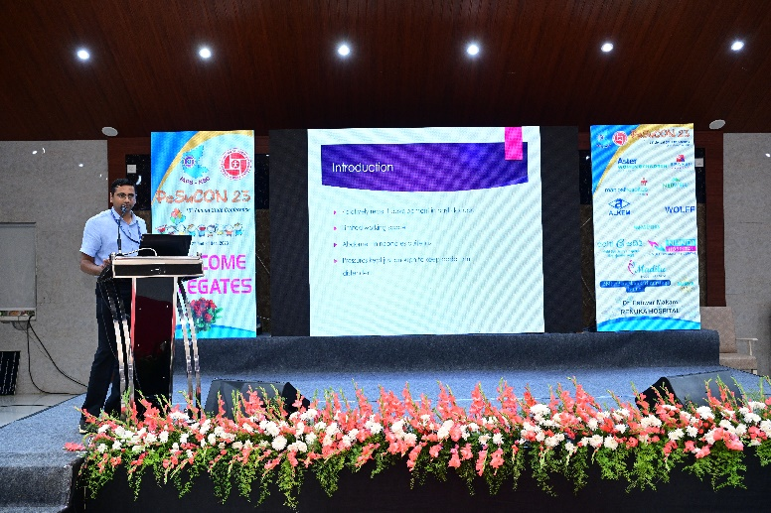

. 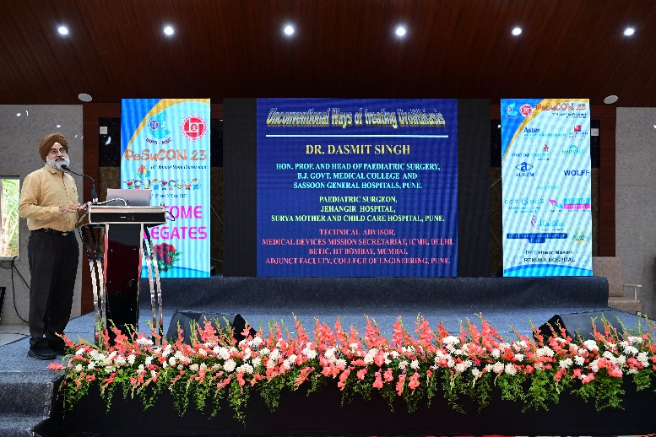

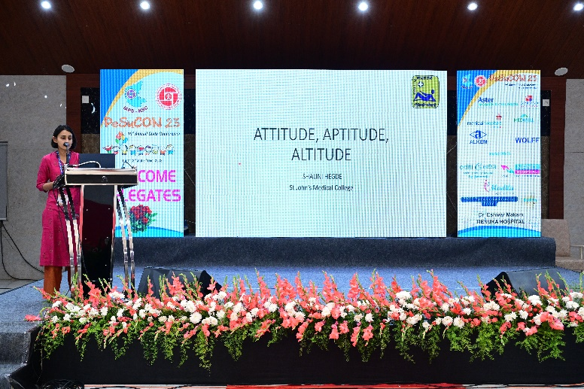

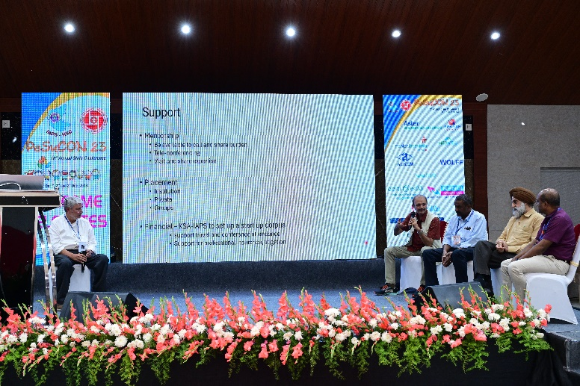

DAY 3 -03-12-2023

PG paper presentation

PGs from various medical colleges presented papers on various topics. PG’s from paediatric surgery, Paediatrics and general surgery participated actively

PAPER PRESENTATION PRIZE DISTRIBUTION

The prize winners for the poster presentation competition were awarded with certificate and mementos.

Paper presentation prize winners:
- Dr Shinoy S Rasalam won the first prize for the paper on tracheostomy and peritoneal dialysis: A must for the paediatric Surgeons armamentarium as life saving in periphery
- Dr Yerrabathin A GuruRavi Tej won the second prize for paper on Retrospective review of ureteric augment in paediatric patient with bladder dysfunction
- Dr Hemantha Mahesh won the third prize for paper on the role of Ommaya reservoir implantation in neonates and preterm with intraventricular hemorrhage.

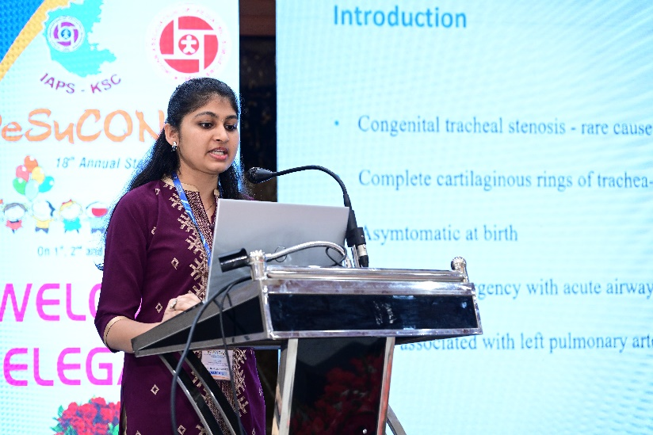

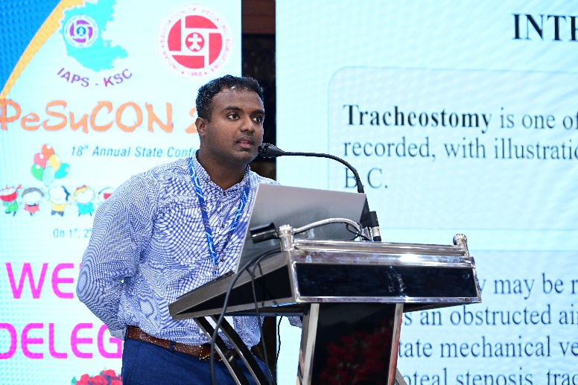

CULTURAL ACTIVITIES

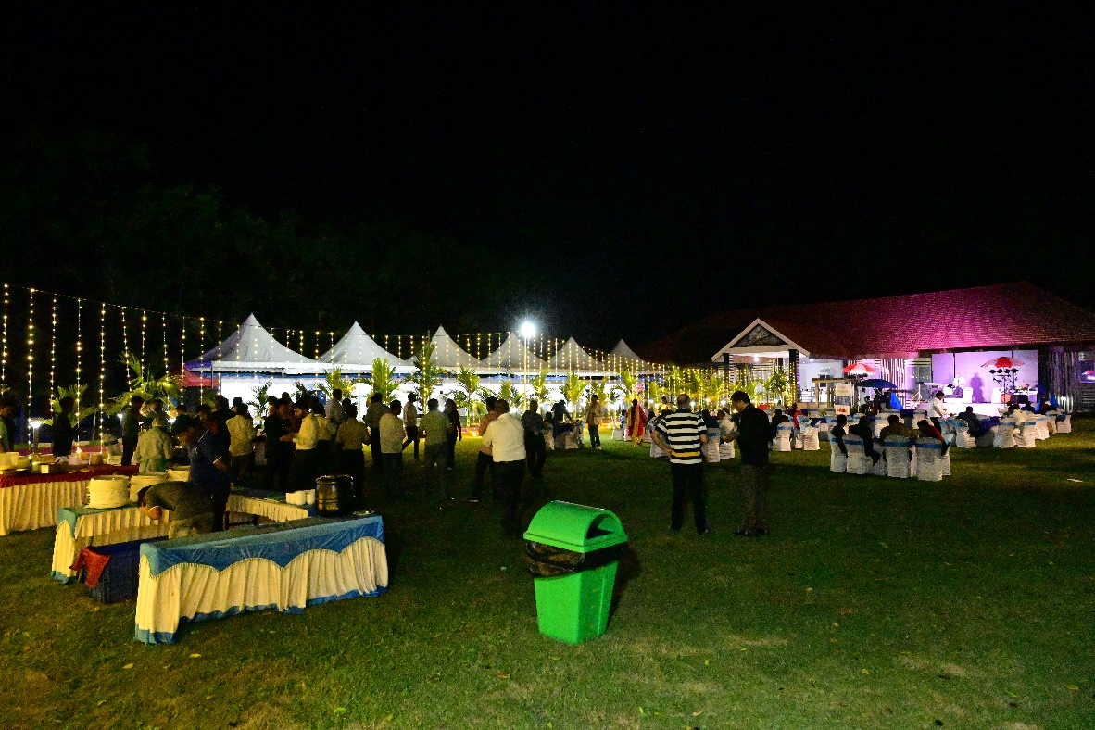

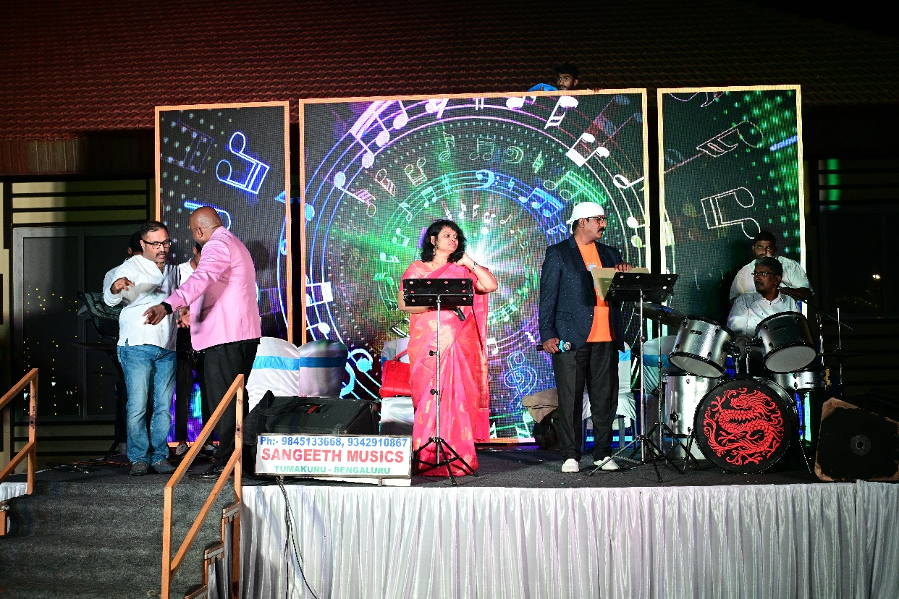
VALEDICTORY FUNCTION

Proceeding Report and Vote of Thanks

Dr. Subramanya K concluded the event by appreciating the efforts of the organising team guest speakers and volunteers, leading to the success of the program.

“Knowledge increases with sharing;
Camaraderie increases with caring.
Both sharing and caring increases
the value of life”.

It gives me immense pleasure to inform you that we conducted the prestigious Paediatric Surgery, 18th annual Karnataka state conference at Tumkuru, the Kalpatharu Nadu. The conference was spanned from 1st to 3rd December. The first day of the conference was held at the Sri Siddhartha Medical College, state-of-the art Sri Nagarjuna Hall. And the following two days were held at the Ankit Vista Holiday Resort; the posh Bandhan Hall.

The sole intention of bringing the Paediatricians and the Paediatric Surgeons on the first day was fulfilled. We had around 80 delegates from both the fraternity attending the scientific sessions. The scientific talks given by the Guru’s were designed to cut to chase for both Postgraduates in both fields and the Practitioners.

The chief guests inaugurated the conference by lighting the lamp, Dr Ramesh Babu (President,IAPS), Dr Vikesh Agarwal (Secretary,IAPS), Dr Narendra Babu (Chairman,IAPS KSC), Dr Yathindra Nanjaiah (Former Prof and HOD Paediartic Surgey SSMC), Dr Subramanya Katteprua (Secretary,IAPS KSC and Prof and HOD Paediatric Surgery, SSMC) and the Guests of Honor joined hands in this auspicious ceremony were Dr K B Lingegowda (Vice-Chancellor, SSAHE), Dr M Z Kurian (Registrar, SSAHE), Dr G N Prabhakara (Vice Principal, SSMC)

The second day, forenoon of the conference dealt with the barely-touched areas of the Peadiatric Surgery. It had semi-live workshop on Retrograde intra-renal surgery and Upper and Lower Gastro-intestinal Paediatric endoscopy. The afternoon session focused on Minimally invasive Paediatric Surgery by the Moguls in the field.

Following on, there were miscellaneous talks about Recent advances in Paediatric Surgery to keep abreast with the current tenor. The icing on the cake towards dusk was the reverse panel discussion on – Deciphering the marketing strategies for Paediatric Surgeons. The long day ended with the Annual General Body meeting and Gala dinner.

The third day, started with a trek to Mandara hills at the dawn; a treadmill test in disguise! And after returning, there was Postgraduate paper presentation from the students.

So, in a nutshell, it was a package of academics, fun and frolic. The master chef has done his best to tickle the palate of the delegates. The annual event was a grand success!

I thank our beloved Chancellor Dr G Parameshwara, the Vice-Chancellor Dr K B Lingegowda G, Registrar Dr Kurian M Z and the Principal of SSMC for their openhearted support for this event. I am indebted to all the seen and unseen hands behind this annual conference success!

I congratulate and thank my colleagues Dr Apurva Bahaskar and Dr Nijgal Matt, the Organising Treasurer and Organising Sceretary respectively on this triumph.

“Hand-in-hand can scale-up a strong union; We the Kids surgeons can scale-up healthy and fit children”

FEEDBACK ABOUT THE CONFERENCE

The feedback about the Conference was delivered by the representatives among the delegates and members of the IAPS KSC & Central IAPS.

